

***HARVEL***

***ELECTRIC***

**E-Project Documentation**

**Teacher Name : MISS SYEDA IMAMA ALI**

**APTECH COMPUTER EDUCATION**

**HYDERABAD-1 PAKISTAN**

**Issue Date : 07-June-2023**

TABLE OF CONTENT

|  |  |  |
| --- | --- | --- |
| **S No** | **Contents** | **Page No** |
| 01 | Certificate | 3 |
| 02 | Acknowledgement | 4 |
| 03 | Project Report | 5 |
| 04 | Problem Definition | 6 |
| 05 | Customer Requirements Specification  (CRS) | 7 |
| 06 | Architecture Design of the Project | 9 |
| 07 | System Requirement | 10 |
| 08 | Task Sheet | 11 |
| 09 | Project Plan | 13 |
| 10 | Checklist of work Progress | 14 |
|  |  |  |
| 11 | Screen Shots | 15 |
| 12 | Source Code | 19 |

CERTIFICATE

This is to certify that

**Muhammad Ammar,**

**Muhammad Muaaz Khan,**

**Faiq ,**

**Zarrar Sikander,**

Has successfully Designed

HARVEL ELECTRIC

Submitted by:

**Muhammad Ammar,**

**Muhammad Muaaz Khan,**

**Faiq ,**

**Zarrar Sikander ,**

Date of Issue: 07-June-2023

**Authorized Signature:** Miss Imama ali

ACKNOWLEDGEMENT

First and foremost, we would like to express our deep gratitude and most heartfelt thanks to almighty ALLAH for his blessings, for lightening up our heart with the torch of knowledge and for giving us the ability to complete this project.

We would like to thanks Aptech Worldwide and the team of E-Project for their generous support and clarifying the doubts regarding e-project. We would like to acknowledge the way of explanation which the team of e-project gave in e-project to make website and we are equally grateful to our teacher (Mam Syeda Imama Ali) for giving us a moral support and guiding us different matters regarding project in all the time about the research and writing of this project.

We are greatly indebted to Aptech Worldwide, Mam Syeda Imama Ali), Faculty Members and ACE Hyderabad, Pakistan for encouragement and incessant help.

PROJECT REPORT

Muhammad Ammar,

Muhammad Muaaz Khan,

Faiq,

Zarrar Sikander,

**Project Title : HARVEL ELECTRIC,**

**Members Name : Muhammad Ammar, Muhammad Muaaz Khan, Faiq, Zarrar Sikander**

**Batch Code : 2212D**

**Start Date : 07-June-20123**

**End Date : 28-June-2023**

**Course : ACCP (CPISM)**

**Teacher : Miss Imama Ali**

**Center Manager : Sir Shoaib Ahmed**

**Center Academic Head : Sir Zubair**

**Center Name : ACE Hyderabad-1, Pakistan**

Submitted as

E Project Documentation

**PROBLEM DEFINITION**

Harvel Electric is selling various electrical products. The company advertises by

distributing the pamphlets, advertising on television and so on. Due to rapid

development in internet field, the company decides to launch a website where people

will get all the information about the various products available with them easily.

Requirement Specification:

The Web site is to be created based on the following requirements.

1) The Home Page should be created making use of Sections with a suitable logo

2) The site should display a menu which will contain the options for brief

introduction about the various products available, location of the shop and

any other information if required.

3) The information should be categorized according to different type of products

like if a User wants to see only ‘FANS’ then he click on a Link/button/menu

etc and he will see different type of FANS. Similarly for ‘GEYSERS’, ‘CFL’ and

other products

4) When a user selects any product type, a list of products for that product type

will be displayed.

5) A brief summary of features of individual products should be displayed on the

Web Page along with the product but detailed Features should be stored in

Individual Word documents which can be downloaded or viewed by the User

who wishes to see the same.

6) Price List should be available for download.

7) There should be a “Contact Us” page which will have the Address of the

Company which is as follows and the mail address which when clicked will

invoke the local mail client from where they can send an email.

**Customer Requirement Specification**

The Web site is to be created based on the following requirements.

1) The Home Page should be created making use of sections with a suitable

logo.

2) Collection must be made more categorized as per the designers and types of

attire.

3) Color combination must be made more précised in the application so that

clothes must be properly highlighted.

4) Navigation needs to be smoother.

5) Comparison of different brands must be included in the website.

6) Gallery section of the boutique’s hit collection must be included.

7) The look and feel of the project must be made user friendly and uniformity in

the color combination must be maintained.

8) About us, Contact Us (address and map) must be added.

9) Images must be added with its alt attribute defined.

PROJECT OBJECTIVE:

The Objective of this program is to give a sample project to work on real life projects. These applications help you build a larger more robust application.

The objective is not to teach you JavaScript/Dreamweaver but to provide you with a real life scenario and help you create basic applications using the tools.

You can revise the chapters before you start with the project.

This project is meant for students who have completed the module of ***Dreamweaver***. These programs should be done in the Lab sessions with assistance of the faculty if required.

It is very essential that a student has a clear understanding of the subject. Students should go through the project and solve the assignments as per requirements given.

Kindly get back @ [eprojects@aptechfze.ae](mailto:eprojects@aptechfze.ae) in case of any doubts regarding the application or its objectives.

Architecture & Design of the Project:

Since the website will have client server architecture it will have one-tier architecture.

System Requirement:

|  |  |  |
| --- | --- | --- |
| **SR.No** | **Items** | **Description** |
| 01 | Operating System | Window XP, Win7 or win8 |
| 02 | Main Processor | Minimum 2ghz or better |
| 03 | Ram (Memory) | Minimum 512mb or better |
| 04 | Web Browser | Google Chrome or Firefox (Latest) |
| 05 | Software | Notepad, HTML editor, Adobe Dreamweaver CS5.5 |

TASK SHEET

|  |  |  |  |  |  |
| --- | --- | --- | --- | --- | --- |
| **Project Ref. No:** | | **Date of Preparation of Activity Plan:** | | | |
| SR.  No | Task | Actual  Start  Date: | Actual  Day: | Team  Mates  Names: | Status: |
| 01 | Planing | 07-June-2023 | 1 | Muhammad ammar,Muhammad Muaaz khan, faiq,zarrar sikandar | YES |
| 02 | Data  Collection | 09-June-2023 | 1 | Muhammad ammar,Muhammad Muaaz khan, faiq,zarrar sikandar | YES |
| 03 | Designing  Home  Page | 14-June-2023 | 4 | Muhammad ammar,Muhammad Muaaz khan, faiq,zarrar sikandar | YES |
| 04 | Linking | 17-June-2023 | 5 | Muhammad ammar,Muhammad Muaaz khan, faiq,zarrar sikandar | YES |
| 05 | Check  Links | 19-June-2023 | 2 | Muhammad ammar,Muhammad Muaaz khan, faiq,zarrar sikandar | YES |
| 06 | Finalizing | 21-June-2023 | 3 | Muhammad ammar,Muhammad Muaaz khan, faiq,zarrar sikandar | YES |
| 07 | Testing | 24-June-2023 | 2 | Muhammad ammar,Muhammad Muaaz khan, faiq,zarrar sikandar | YES |
| 08 | Documentation | 26-June-2023 | 1 | Muhammad ammar,Muhammad Muaaz khan, faiq,zarrar sikand | YES |
| 09 | Uploading | 27-June-2023 | 2 | Muhammad ammar,Muhammad Muaaz khan, faiq,zarrar sikandarS | YES |

PROJECT PLAN

* Website is able to execute quickly.
* The color scheme of the site looks attractive.
* The collection of data is authentic and taken by the most popular product websites.
* There is authentic information of facilities products with their specifications.
* Background is different to main page.
* The HOME is well prepared exactly for the same page as user clicks on the link..
* A visitor can also view the individual image of our every gallery.

CHECK LIST OF WORK PROGRESS

|  |  |  |
| --- | --- | --- |
| **SR.No** | **Aspect Tested** | **Remarks** |
| 01 | Data Collection | **yes** |
| 02 | Designing Home Page | **yes** |
| 05 | Linking The Pages | **yes** |
| 06 | Finalization | **Yes** |
| 08 | Tasting The Site | **Yes** |
| 09 | Documentation | **yes** |

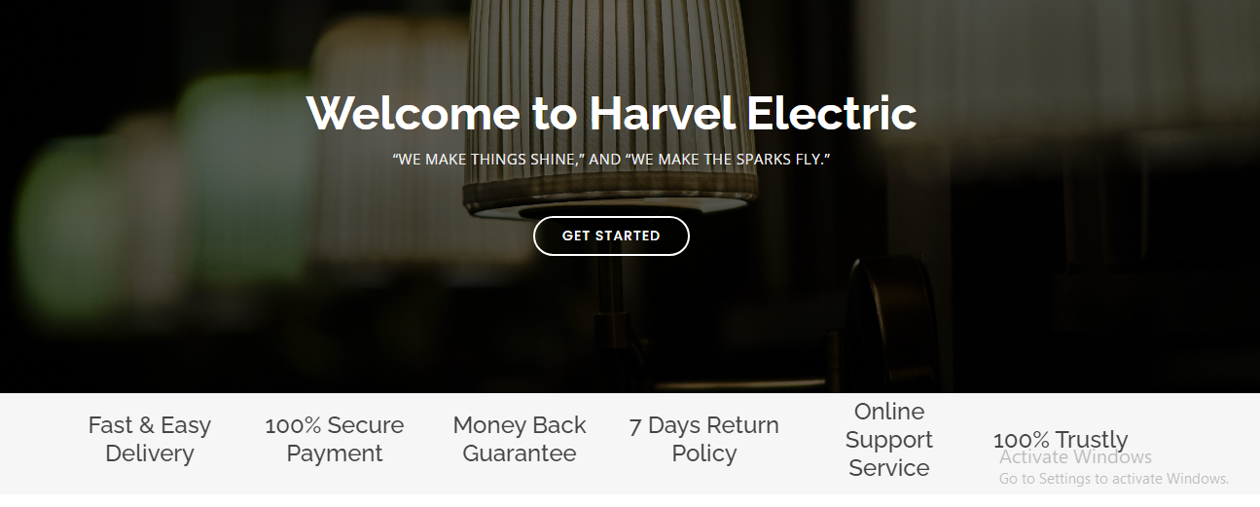

SCREEN SHOTS

Home-page-1

About

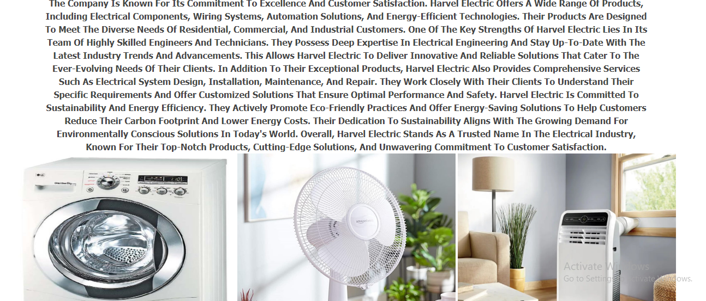

Products

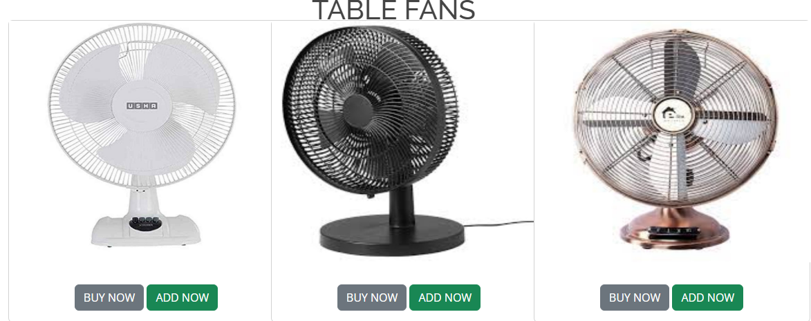

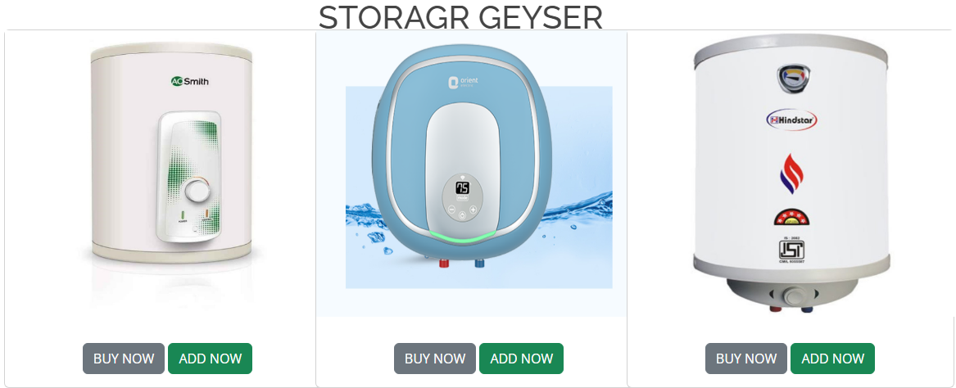

Contact-us

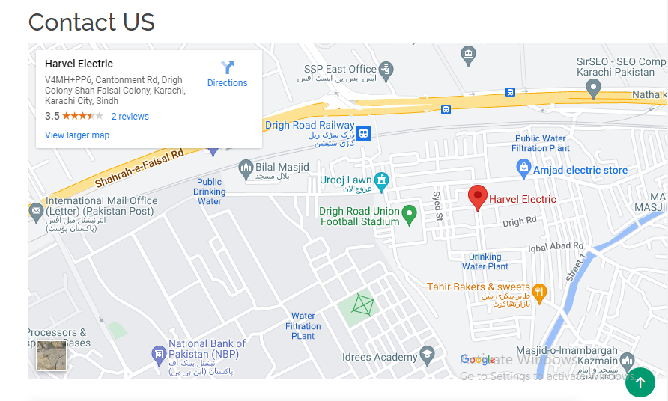

SOURCE CODE

<<!DOCTYPE html>

<html lang="en">

<head>

  <meta charset="utf-8">

  <meta content="width=device-width, initial-scale=1.0" name="viewport">

  <title>Harvel Electric - Index</title>

  <meta content="" name="description">

  <meta content="" name="keywords">

  <!-- Favicons -->

  <link href="image/HARVEL ELECTRIC LOGO.png " rel="icon">

  <link href="image/HARVEL ELECTRIC LOGO.png" rel="apple-touch-icon">

  <!-- Google Fonts -->

  <link href="https://fonts.googleapis.com/css?family=Open+Sans:300,300i,400,400i,600,600i,700,700i|Raleway:300,300i,400,400i,500,500i,600,600i,700,700i|Poppins:300,300i,400,400i,500,500i,600,600i,700,700i" rel="stylesheet">

  <!-- Vendor CSS Files -->

  <link href="assets/vendor/aos/aos.css" rel="stylesheet">

  <link href="assets/vendor/bootstrap/css/bootstrap.min.css" rel="stylesheet">

  <link href="assets/vendor/bootstrap-icons/bootstrap-icons.css" rel="stylesheet">

  <link href="assets/vendor/boxicons/css/boxicons.min.css" rel="stylesheet">

  <link href="assets/vendor/glightbox/css/glightbox.min.css" rel="stylesheet">

  <link href="assets/vendor/remixicon/remixicon.css" rel="stylesheet">

  <link href="assets/vendor/swiper/swiper-bundle.min.css" rel="stylesheet">

  <!-- Template Main CSS File -->

  <link href="assets/css/style.css" rel="stylesheet">

</head>

<body>

  <!-- ======= Header ======= -->

  <header id="header" class="fixed-top d-flex align-items-center">

    <div class="container">

      <div class="header-container d-flex align-items-center justify-content-between">

        <div class="logo">

          <h1 class="text-dark"><a href="index.html"><span><img src="image/HARVEL ELECTRIC LOGO.png" alt="" width="125px"></span></a></h1>

          <!-- Uncomment below if you prefer to use an image logo -->

          <!-- <a href="index.html"><img src="assets/img/logo.png" alt="" class="img-fluid"></a>-->

        </div>

        <nav id="navbar" class="navbar">

          <ul>

            <li><a class="nav-link scrollto active" href="index.html">Home</a></li>

            <li><a class="nav-link scrollto" href="about.html">About</a></li>

            <li><a class="nav-link scrollto" href="service.html">Services</a></li>

            <li><a class="nav-link scrollto " href="portfolio-details.html">Portfolio</a></li>

            <li class="dropdown"><a href="#"><span>PRODUCTS</span> <i class="bi bi-chevron-down"></i></a>

              <ul>

                <li class="dropdown"><a href=""><span>AIR CONDIONER</span> <i class="bi bi-chevron-right"></i></a>

                  <ul>

                    <li><a href="invertor.html">INVETER </a></li>

                    <li><a href="port.html">Portable Air Conditioner</a></li>

                    <li><a href="window.html">Window Ac</a></li>

                  </ul>

                </li>

                <li class="dropdown"><a href=""><span>Fan</span> <i class="bi bi-chevron-right"></i></a>

                  <ul>

                    <li><a href="tab.html">Table Fans </a></li>

                    <li><a href="ex.html">Exhaust Fans</a></li>

                    <li><a href="ceil.html">Ceiling Fans</a></li>

                  </ul>

                </li>

                <li class="dropdown"><a href="#"><span> geyser</span> <i class="bi bi-chevron-right"></i></a>

                  <ul>

                    <li><a href="ins.html">Instant geysers</a></li>

                    <li><a href="storage.html">Storage geysers</a></li>

                  </ul>

                </li>

                <li class="dropdown"><a href="#"><span>Washing Machine</span> <i class="bi bi-chevron-right"></i></a>

                  <ul>

                    <li><a href="auto.html">Fully automatic washing machine</a></li>

                    <li><a href="front.html">Front load washing machine.</a></li>

                  </ul>

                </li>

              </ul>

            </li>

            <li><a class="nav-link scrollto" href="contact.html">Contact US</a></li>

            <li><a class="getstarted scrollto" href="about.html">Get Started</a></li>

          </ul>

          <i class="bi bi-list mobile-nav-toggle"></i>

        </nav><!-- .navbar -->

      </div><!-- End Header Container -->

    </div>

  </header><!-- End Header -->

  <!-- ======= Hero Section ======= -->

  <section id="hero" class="d-flex align-items-center">

    <div class="container text-center position-relative" data-aos="fade-in" data-aos-delay="200">

      <h1>Welcome to Harvel Electric</h1>

      <h2>“We Make Things Shine,” and “We Make the Sparks Fly.” </h2>

      <a href="#about" class="btn-get-started scrollto">Get Started</a>

    </div>

  </section><!-- End Hero -->

  <main id="main">

    <!-- ======= Clients Section ======= -->

    <section id="clients" class="clients">

      <div class="container">

        <div class="row">

          <div class="col-lg-2 col-md-4 col-6 d-flex align-items-center" data-aos="zoom-in" data-aos-delay="100">

            <h4>Fast & Easy Delivery  </h4  >

          </div>

          <div class="col-lg-2 col-md-4 col-6 d-flex align-items-center" data-aos="zoom-in" data-aos-delay="200">

           <h4>100% Secure Payment</h4>

          </div>

          <div class="col-lg-2 col-md-4 col-6 d-flex align-items-center" data-aos="zoom-in" data-aos-delay="300">

            <h4>Money Back Guarantee</h4>

          </div>

          <div class="col-lg-2 col-md-4 col-6 d-flex align-items-center" data-aos="zoom-in" data-aos-delay="400">

          <h4>7 Days Return Policy</h4>

          </div>

          <div class="col-lg-2 col-md-4 col-6 d-flex align-items-center" data-aos="zoom-in" data-aos-delay="500">

            <h4>Online Support Service</h4>

          </div>

          <div class="col-lg-2 col-md-4 col-6 d-flex align-items-center" data-aos="zoom-in" data-aos-delay="600">

          <h4>100% Trustly</h4>

          </div>

        </div>

      </div>

    </section><!-- End Clients Section -->

    <!-- ======= About Section ======= -->

    <section id="about" class="about">

      <div class="container">

        <div class="row content">

          <div class="col-lg-6" data-aos="fade-right" data-aos-delay="100">

            <h2>Eum ipsam laborum deleniti velitena</h2>

            <h3>Voluptatem dignissimos provident quasi corporis voluptates sit assum perenda sruen jonee trave</h3>

          </div>

          <div class="col-lg-6 pt-4 pt-lg-0" data-aos="fade-left" data-aos-delay="200">

            <p>

              Ullamco laboris nisi ut aliquip ex ea commodo consequat. Duis aute irure dolor in reprehenderit in voluptate

              velit esse cillum dolore eu fugiat nulla pariatur. Excepteur sint occaecat cupidatat non proident, sunt in

              culpa qui officia deserunt mollit anim id est laborum

            </p>

            <ul>

              <li><i class="ri-check-double-line"></i> Ullamco laboris nisi ut aliquip ex ea commodo consequa</li>

              <li><i class="ri-check-double-line"></i> Duis aute irure dolor in reprehenderit in voluptate velit</li>

              <li><i class="ri-check-double-line"></i> Ullamco laboris nisi ut aliquip ex ea commodo consequat. Duis aute irure dolor in reprehenderit in</li>

            </ul>

            <p class="fst-italic">

              Lorem ipsum dolor sit amet, consectetur adipiscing elit, sed do eiusmod tempor incididunt ut labore et dolore

              magna aliqua.

            </p>

          </div>

        </div>

      </div>

    </section><!-- End About Section -->

    <!-- ======= Counts Section ======= -->

    <section id="counts" class="counts">

      <div class="container">

        <div class="row counters">

          <div class="col-lg-3 col-6 text-center">

            <span data-purecounter-start="0" data-purecounter-end="232" data-purecounter-duration="1" class="purecounter"></span>

            <p>Clients</p>

          </div>

          <div class="col-lg-3 col-6 text-center">

            <span data-purecounter-start="0" data-purecounter-end="521" data-purecounter-duration="1" class="purecounter"></span>

            <p>Projects</p>

          </div>

          <div class="col-lg-3 col-6 text-center">

            <span data-purecounter-start="0" data-purecounter-end="1463" data-purecounter-duration="1" class="purecounter"></span>

            <p>Hours Of Support</p>

          </div>

          <div class="col-lg-3 col-6 text-center">

            <span data-purecounter-start="0" data-purecounter-end="15" data-purecounter-duration="1" class="purecounter"></span>

            <p>Hard Workers</p>

          </div>

        </div>

      </div>

    </section><!-- End Counts Section -->

    <!-- ======= Why Us Section ======= -->

    <section id="why-us" class="why-us">

      <div class="container">

        <div class="row">

          <div class="col-lg-4 d-flex align-items-stretch" data-aos="fade-right">

            <div class="content">

              <h3>Why Choose Harvel Electric??</h3>

              <p>

                Lorem ipsum dolor sit amet, consectetur adipiscing elit, sed do eiusmod tempor incididunt ut labore et dolore magna aliqua. Duis aute irure dolor in reprehenderit

                Asperiores dolores sed et. Tenetur quia eos. Autem tempore quibusdam vel necessitatibus optio ad corporis.

              </p>

              <div class="text-center">

                <a href="#" class="more-btn">Learn More <i class="bx bx-chevron-right"></i></a>

              </div>

            </div>

          </div>

          <div class="col-lg-8 d-flex align-items-stretch">

            <div class="icon-boxes d-flex flex-column justify-content-center">

              <div class="row">

                <div class="col-xl-4 d-flex align-items-stretch" data-aos="zoom-in" data-aos-delay="100">

                  <div class="icon-box mt-4 mt-xl-0">

                    <i class="bx bx-receipt"></i>

                    <h4>Corporis voluptates sit</h4>

                    <p>Consequuntur sunt aut quasi enim aliquam quae harum pariatur laboris nisi ut aliquip</p>

                  </div>

                </div>

      </div>

    </section><!-- End Why Us Section -->

    <!-- ======= Cta Section ======= -->

      </div>

    </section><!-- End Cta Section -->

    <!-- ======= Services Section ======= -->

    <!-- ======= Contact Section ======= -->

  <!-- ======= Footer ======= -->

        </div>

      </div>

    </div>

        <div class="credits">

         <a href="https://bootstrapmade.com/"></a>

        </div>

      </div>

      <div class="social-links text-center text-md-right pt-3 pt-md-0">

        <a href="#" class="twitter"><i class="bx bxl-twitter"></i></a>

        <a href="#" class="facebook"><i class="bx bxl-facebook"></i></a>

        <a href="#" class="instagram"><i class="bx bxl-instagram"></i></a>

        <a href="#" class="google-plus"><i class="bx bxl-skype"></i></a>

        <a href="#" class="linkedin"><i class="bx bxl-linkedin"></i></a>

      </div>

    </div>

  </footer><!-- End Footer -->

  <a href="#" class="back-to-top d-flex align-items-center justify-content-center"><i class="bi bi-arrow-up-short"></i></a>

  <!-- Vendor JS Files -->

  <script src="assets/vendor/purecounter/purecounter_vanilla.js"></script>

  <script src="assets/vendor/aos/aos.js"></script>

  <script src="assets/vendor/bootstrap/js/bootstrap.bundle.min.js"></script>

  <script src="assets/vendor/glightbox/js/glightbox.min.js"></script>

  <script src="assets/vendor/isotope-layout/isotope.pkgd.min.js"></script>

  <script src="assets/vendor/swiper/swiper-bundle.min.js"></script>

  <script src="assets/vendor/php-email-form/validate.js"></script>

  <!-- Template Main JS File -->

  <script src="assets/js/main.js"></script>

</body>

</html>

Thankyou